Data Analysis 2021 Spring





# Lecture 05:

**Linear Regression I**

March 31 & April 5, 2021

**Taesoo Kwon**

[tskwon@seoultech.ac.kr](mailto:tskwon@seoultech.ac.kr)

©copyright CIEL 2015 https://ciel.seoultech.ac.kr/

### Course Schedule (Tentative)

|  |  |  |  |  |
| --- | --- | --- | --- | --- |
| **Week** | **Topics** | **Note** | **Date (W)** | **Date (M)** |
| 1 | Orientation, Statistical Learning (Ch2) | Online | 03/03 | 03/08 |
| 2 | Statistical Learning (Ch2), Python Programming | Online | 03/10 | 03/15 |
| 3 | Probability & Statistics | Online | 03/17 | 03/22 |
| 4 | Probability & Statistics | Online | 03/24 | 03/29 |
| **5** | Linear Regression (Ch3) | Online | 03/31 | 04/05 |
| 6 | Linear Regression (Ch3) | Online | 04/07 | 04/12 |
| 7 | Classification (Ch4) | Online | 04/14 | 04/19 |
| 8 | **Midterm exam** | **7pm or Class hours (W1-W7)** | **04/21or26** | **04/21or26** |
| 9 | Resampling Methods (Ch5) | Online | 04/28 | 05/03 |
| 10 | Linear Model Selection and Regularization (Ch6) | Online | 05/05 | 05/10 |
| 11 | Moving Beyond Linearity (Ch7) | Online | 05/12 | 05/17 |
| 12 | Tree-Based Methods (Ch8) | Online | 05/19 | 05/24 |
| 13 | Support Vector Machines (Ch9) | Online | 05/26 | 05/31 |
| 14 | Unsupervised Learning (Ch10) | Online | 06/02 | 06/07 |
| 15 | **Final exam** | **7pm or Class hours (W9-W14)** | **06/09or14** | **06/09or14** |

©copyright CIEL 2015 **2**

#### Basics for linear regression



**OUTLINES**

* Simple linear regression [Ch3.1]
* Preliminaries for multiple linear regression
* Summary & Next class

©copyright CIEL 2015



# Basics for Linear Regression



## : [Ross] Ch9

* + Basics for Linear Regression
  + Simple linear regression
  + Preliminaries for multiple linear regression
  + Summary & Next class

©copyright CIEL 2015 https://ciel.seoultech.ac.kr/

**[Review] Probability & Statistics for SL**

#### Summarizing data sets

* Probability
  + Mean, variance, covariance
  + Covariance matrix

#### Distributions

* + Normal, Chi-squared, t-distribution, F-distribution

#### Weak law of large number, central limit theorem

* Sample mean, Sample variance
* Unbiased estimator
* Confidence interval
* Hypothesis Test: mean (w/ known & unknown variance), variance
* (Linear regression)

©copyright CIEL 2015 **5**

### Basics for Probability & Statistics

#### Basics for probability & statistics → Last week

* + Descriptive Statistics: [Ross] Ch1, Ch2
  + Probability & Random variables: [Ross] Ch3, Ch4
  + Special random variables: [Ross] Ch5

#### Statistical inference

* + Distributions of sampling statistics: [Ross] Ch6
  + Parameter estimation: [Ross] Ch7
  + Hypothesis testing: [Ross] Ch8
* Basics for linear regression: [Ross] Ch9 [Ross] S. M. Ross, Introduction to probability and statistics for engineers and scientists, 6th ed., Academic Press, 2021.

©copyright CIEL 2015 **6**

### Introduction to Regression

#### Linear relationship between dependent variable 𝑌𝑌 and independent variables 𝑥𝑥1, ⋯ , 𝑥𝑥𝑟𝑟

* + Dependent variable 𝑌𝑌: output, response, or target
  + Independent variables 𝑥𝑥1, ⋯ , 𝑥𝑥𝑟𝑟: input, predictor, or feature
  + For regression coefficients 𝛽𝛽1, 𝛽𝛽2, ⋯ , 𝛽𝛽𝑟𝑟 (estimated from data set)



* + Linear regression equation subject to random error 𝑒𝑒 with mean 0
    - Regression of 𝑌𝑌 on set of independent variables 𝑥𝑥1, ⋯ , 𝑥𝑥𝑟𝑟



* + Expected response given input 𝐱𝐱 =
  + For single independent variable (i.e., 𝑟𝑟 = 1), simple regression

𝑥𝑥1, ⋯ , 𝑥𝑥𝑟𝑟



* + For many independent variables, multiple linear regression

©copyright CIEL 2015 **7**

### Introduction to Regression [cont.]

#### Example

* + Percent yield of a laboratory experiment (𝑦𝑦) vs. temperature at which experiment was run (𝑥𝑥)
  + 10 data pairs

𝑥𝑥𝑖𝑖 , 𝑦𝑦𝑖𝑖

* + Scatter diagram

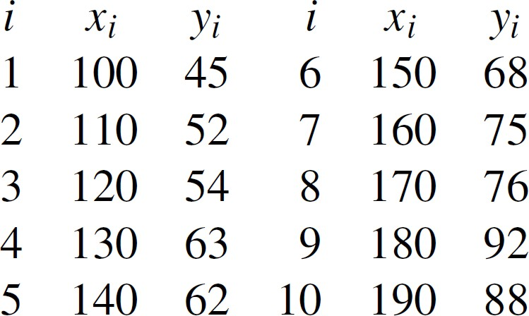

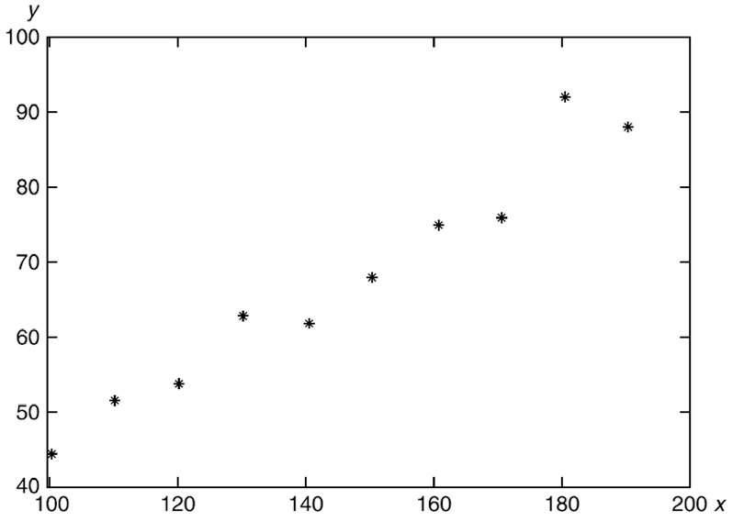

Simple linear regression model appropriate

©copyright CIEL 2015 **8**

### Least Squares Estimators of Regression Parameters

#### Estimate 𝛼𝛼 and 𝛽𝛽 in a simple linear regression model 𝑌𝑌 = 𝛼𝛼 + 𝛽𝛽𝑥𝑥 + 𝑒𝑒

* + 𝐴𝐴 : estimator of 𝛼𝛼, 𝐵𝐵 : estimator of 𝛽𝛽
  + 𝑥𝑥𝑖𝑖 : input variable, 𝐴𝐴 + 𝐵𝐵𝑥𝑥𝑖𝑖 : estimator of response, 𝑌𝑌𝑖𝑖 : actual response
  + 𝑌𝑌𝑖𝑖 − 𝐴𝐴 − 𝐵𝐵𝑥𝑥𝑖𝑖 : Residual
  + 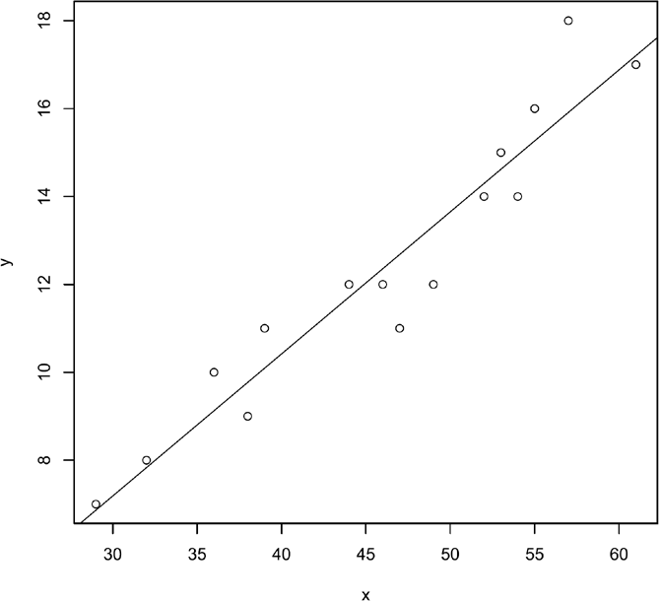𝑆𝑆𝑆𝑆: sum of squared difference

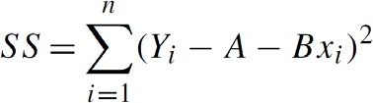

* + Least squares estimator of 𝛽𝛽 and 𝛼𝛼 such that they minimize 𝑆𝑆𝑆𝑆

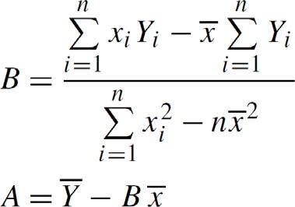

* + - Straight line 𝐴𝐴 + 𝐵𝐵𝑥𝑥: estimated regression line

©copyright CIEL 2015 **9**

### [FYI] Derivation of Least Squares Estimators of Regression Parameters

#### Find 𝐴𝐴 and 𝐵𝐵 to minimize

Convex w.r.t. 𝐴𝐴 and 𝐵𝐵

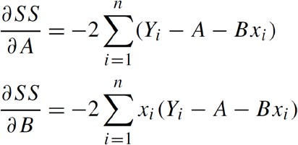

=

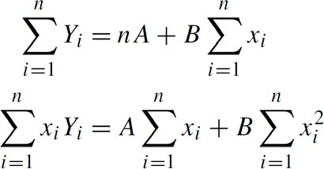

Normal equation

0

= 0







©copyright CIEL 2015 **10**

**Distributions of Estimators** 𝑨𝑨 **and** 𝑩𝑩

#### i.i.d. random error ~ normal distribution 𝑁𝑁 :

0, 𝜎𝜎2

* + Notation ▪ Results

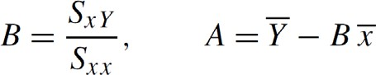

**Unbiased estimators**

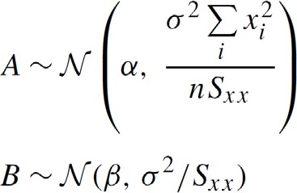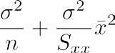

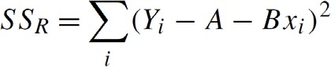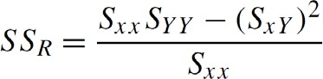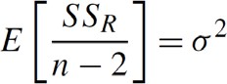For

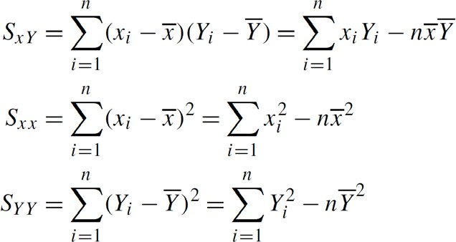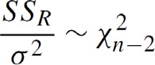

Independent of 𝐴𝐴 and 𝐵𝐵

©copyright CIEL 2015 **11**

### [FYI] Derivation of Distributions of Estimator 𝑩𝑩

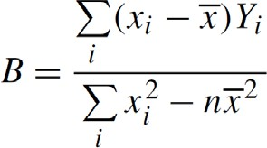

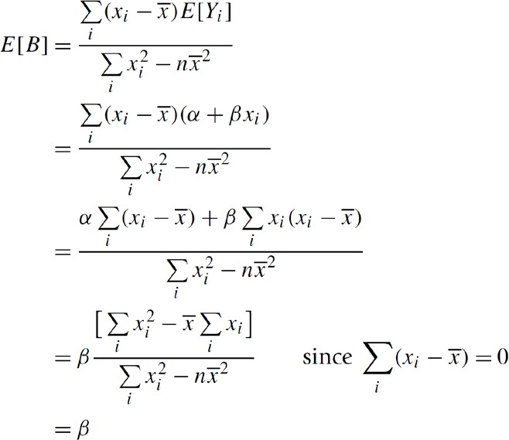©copyright CIEL 2015 **12**

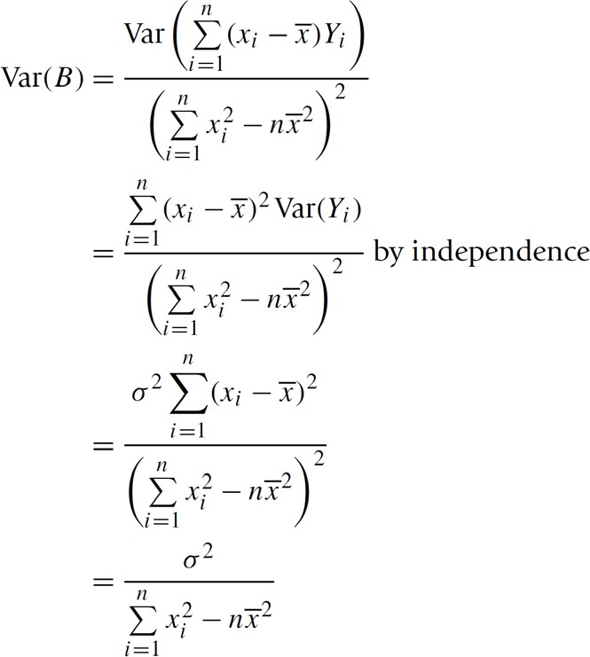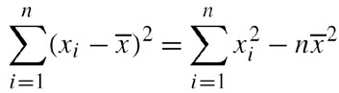

### [FYI] Derivation of Distributions of Estimator 𝑨𝑨

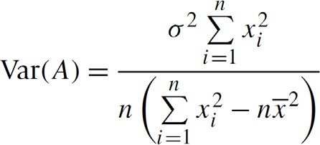

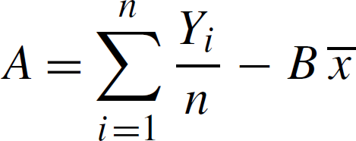

[Proof]

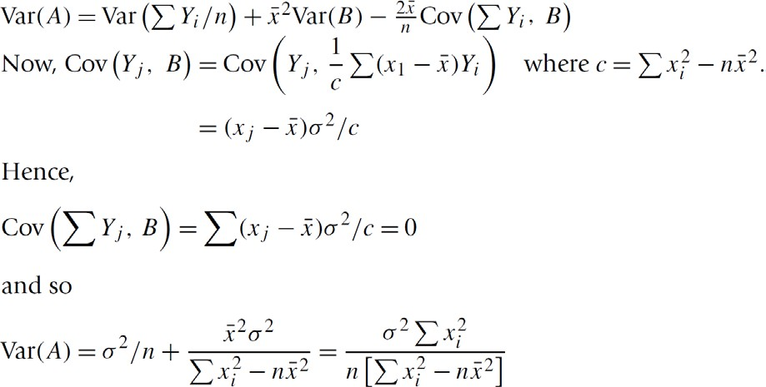

©copyright CIEL 2015 **13**

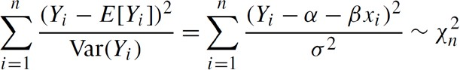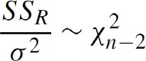**[FYI] Derivation of Distributions of** 𝑺𝑺𝑺𝑺𝑹𝑹



**2 dofs lost**

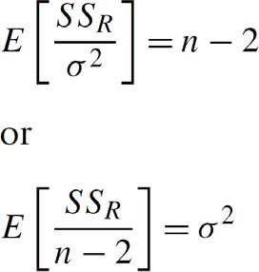

©copyright CIEL 2015 **14**

### Inference Concerning 𝜷𝜷

#### Hypothesis testing for 𝛽𝛽: e.g., response not depending on input?





* + From distribution of 𝛽𝛽:

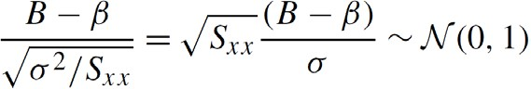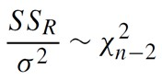

Unknown

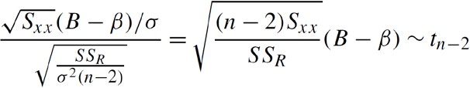

~Normal

~Square root of

𝜒𝜒2

𝑛𝑛−2

/(𝑛𝑛 − 2)

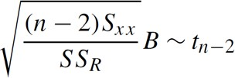

* + Significance level 𝛾𝛾 test of 𝐻𝐻0

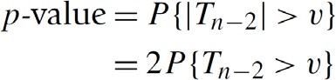

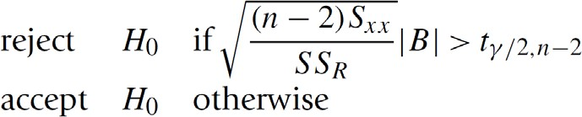

𝑃𝑃

𝑡𝑡30 > 2.04

= 0.025, 𝑃𝑃

= 0.005

©copyright CIEL 2015 **15**

𝑡𝑡30 > 2.75

### Inference Concerning 𝜷𝜷 [cont.]

#### Confidence interval estimator for 𝛽𝛽

1 − 𝑎𝑎

* + 100

percent confidence interval estimator of 𝛽𝛽

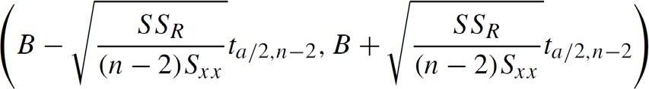

* + Derivation

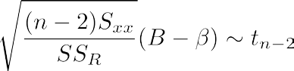

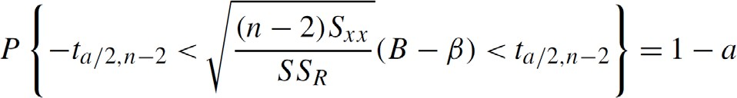

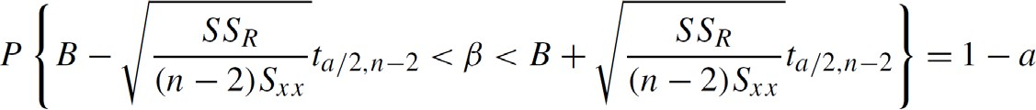©copyright CIEL 2015 **16**

### Inference Concerning 𝜶𝜶

#### Hypothesis testing for 𝛼𝛼: exactly the same approach as the one for 𝛽𝛽



▪

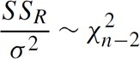

* + 100

percent confidence interval estimator of 𝛼𝛼

1 − 𝑎𝑎

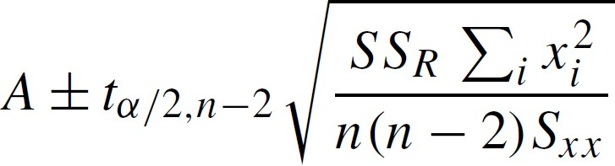

©copyright CIEL 2015 **17**

### Inferences about Simple Linear Regression

#### Regression parameters

* [FYI] Mean response & Future response

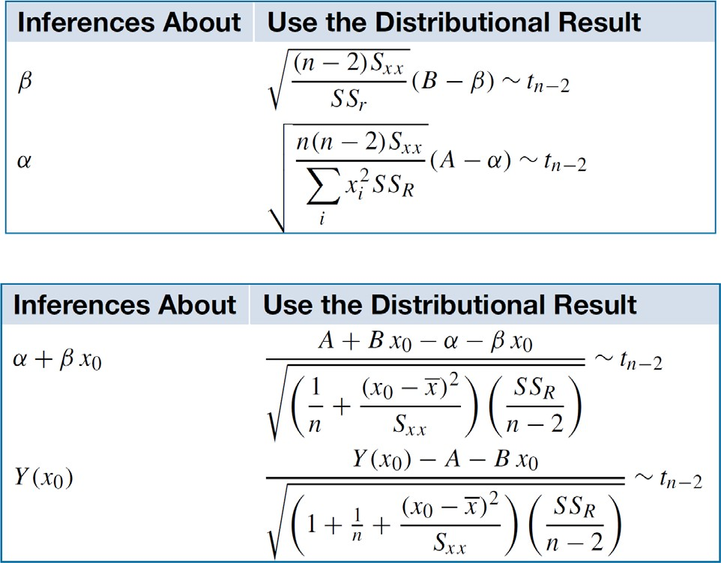

©copyright CIEL 2015 **18**

### Coefficient of Determination & Sample Correlation Coefficient

#### Variation in 𝑌𝑌𝑖𝑖 values due to

* + First, different input values 𝑥𝑥𝑖𝑖
  + Second, random error with mean 0 and variance 𝜎𝜎2

#### Total variation of 𝑌𝑌𝑖𝑖 values:

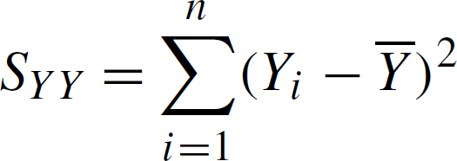

* Inherent variation of 𝑌𝑌𝑖𝑖 values after different input values have been taken into account

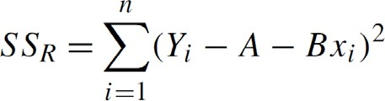

* Coefficient of determination 𝑅𝑅2
  + Amount of variation in response variables explained by different input values

o 0 ≤ 𝑅𝑅2 ≤ 1

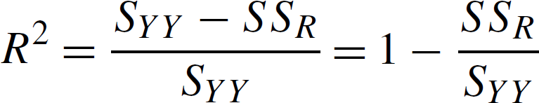

* + - Available for multiple variables as well as a single variable

©copyright CIEL 2015 **19**

### Coefficient of Determination & Sample Correlation Coefficient [cont.]

#### Recall sample correlation coefficient

o −1 ≤ 𝑟𝑟 ≤ 1

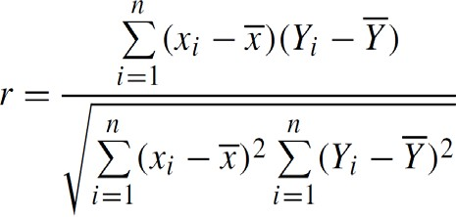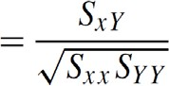

* + o Only for a single pair of variables
    - Both of 𝑅𝑅2 and 𝑟𝑟 can be used as an indicator of how well the regression model fits data
  + 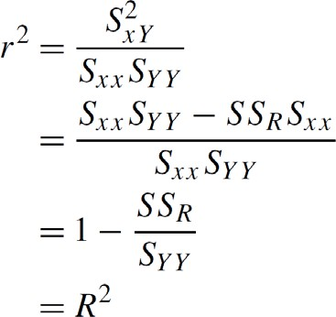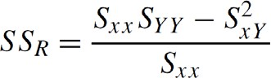For a single input variable,



©copyright CIEL 2015 **20**



# Simple Linear Regression



## : Ch3.1

#### Basics for Linear Regression

* Simple linear regression
* Preliminaries for multiple linear regression
* Summary & Next class

©copyright CIEL 2015 https://ciel.seoultech.ac.kr/

**Linear Regression**

#### Linear regression is a simple approach to supervised learning

* + It assumes that the dependence of 𝑌𝑌 on 𝑋𝑋1, 𝑋𝑋2, ⋯ , 𝑋𝑋𝑝𝑝 is linear

#### True regression functions are never linear!

* Although it may seem overly simplistic, linear regression is extremely useful both conceptually and practically

©copyright CIEL 2015 **22**

### Linear Regression for Advertising Data

#### Consider the advertising data shown on the next slide

* Questions we might ask:
  + Is there a relationship between advertising budget and sales?
  + How strong is the relationship between advertising budget and sales?
  + Which media contribute to sales?
  + How accurately can we predict future sales?
  + Is the relationship linear?
  + Is there synergy among the advertising media?

©copyright CIEL 2015 **23**

### Advertising Data

©copyright CIEL 2015 **24**

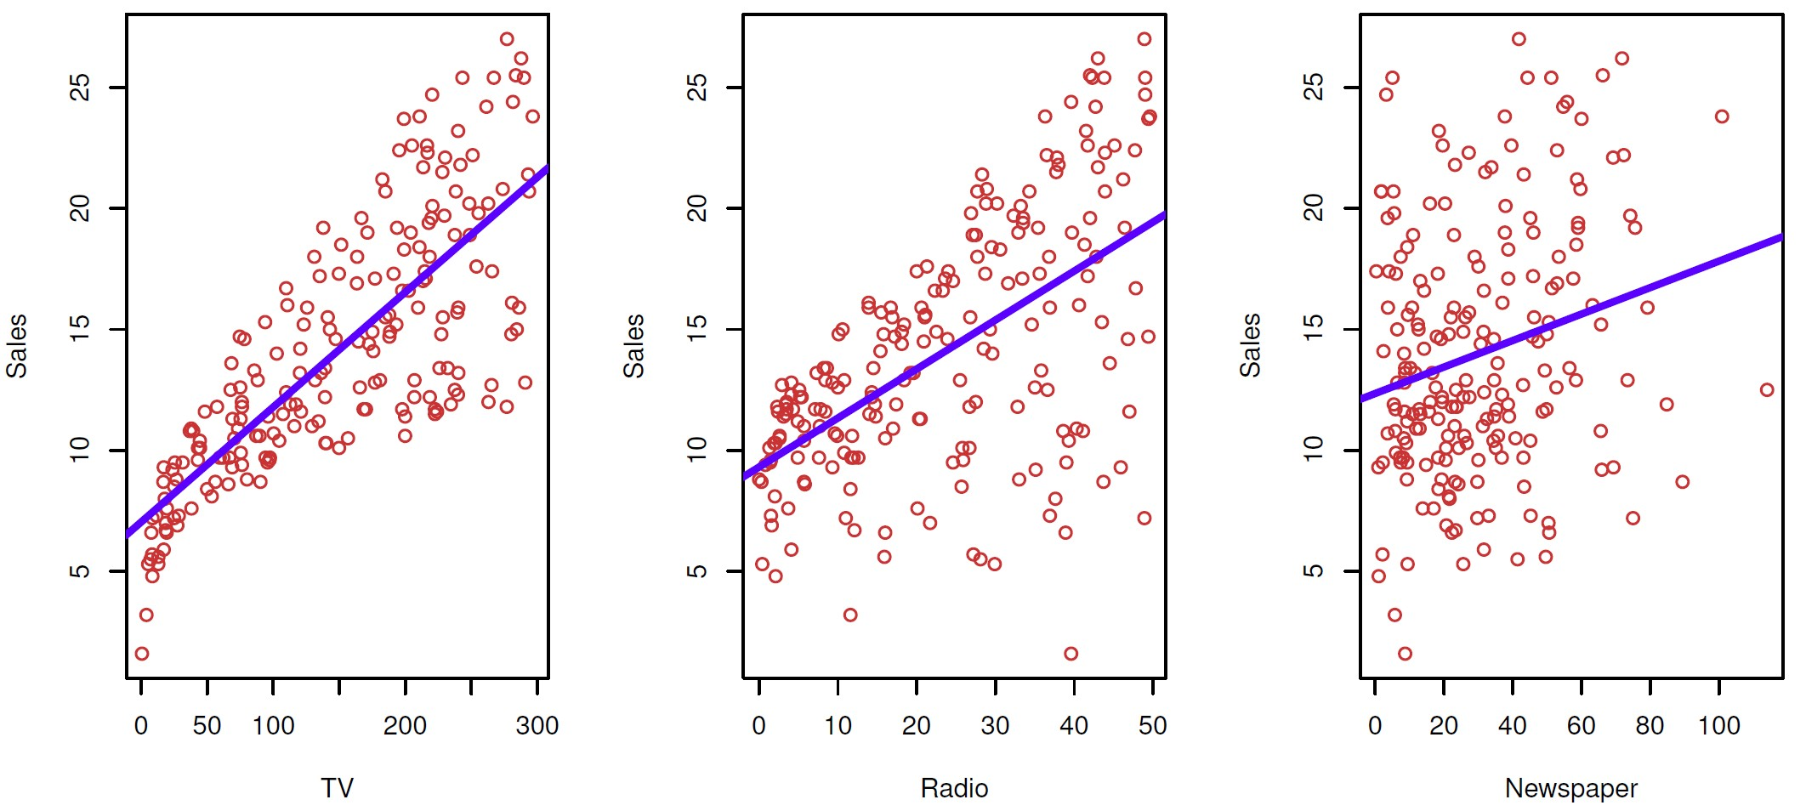

### Simple Linear Regression Using a Single Predictor 𝑿𝑿

#### We assume a model



* + 𝛽𝛽0 and 𝛽𝛽1 are two unknown constants that represent the intercept and slope, also known as coefficients or parameters, and 𝜖𝜖 is the error term

1

#### Given some estimates

0

𝛽𝛽̂

and

#### 𝛽𝛽̂

for the model coefficients, we predict future sales using



* + 𝑦𝑦�

indicates a prediction of 𝑌𝑌 on the basis of 𝑋𝑋 = 𝑥𝑥

* + - The hat symbol denotes an estimated value

©copyright CIEL 2015 **25**

### Estimation of Parameters by Least Squares

#### Residual: the 𝑖𝑖th residual

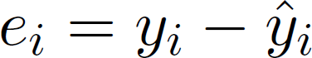

* + 𝑦𝑦�𝑖𝑖 =

0

𝛽𝛽̂

+ 𝛽𝛽̂

𝑥𝑥𝑖𝑖

: prediction for 𝑌𝑌 based on the 𝑖𝑖th value of 𝑋𝑋

#### Residual sum of squares (RSS):



Ross



1

* + Equivalently,

1



#### The least squares approach chooses

0

* + Minimizing values

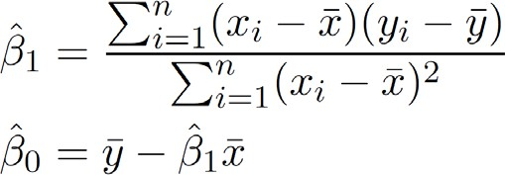

#### 𝛽𝛽̂

and

#### 𝛽𝛽̂

to minimize RSS

Ross

o 𝑦𝑦� ≡ 1 ∑𝑛𝑛 𝑦𝑦

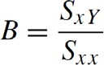

and

𝑥𝑥

≡ 1 ∑𝑛𝑛 𝑥𝑥

are the sample means

𝑛𝑛

𝑖𝑖=1

𝑖𝑖

𝑛𝑛

𝑖𝑖=1

𝑖𝑖

©copyright CIEL 2015 **26**

### Example: Advertising Data

#### The least squares for the regression of Sales onto TV

* + 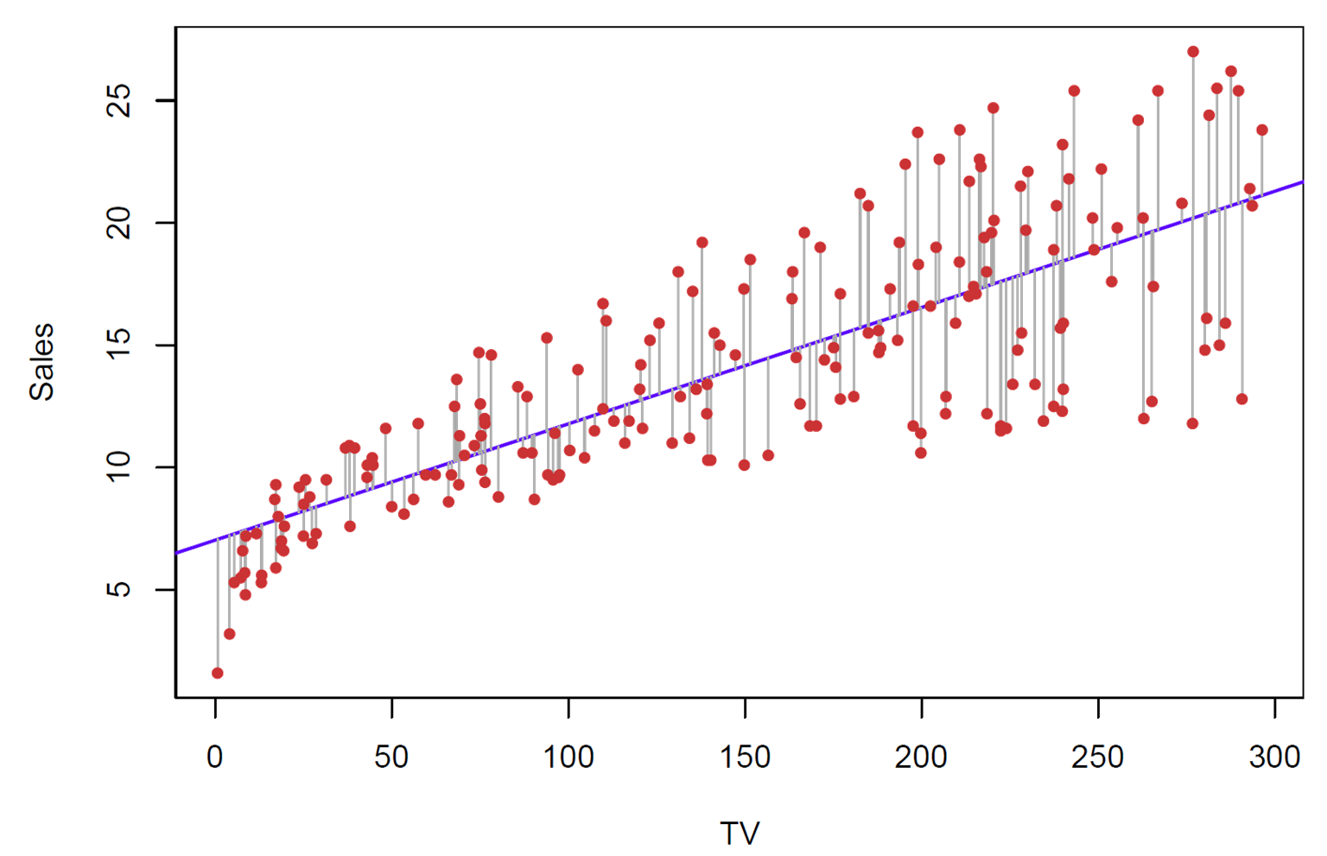In this case a linear captures the essence of the relationship, although it is somewhat deficient in the left of the plot

©copyright CIEL 2015 **27**

### Assessing Accuracy of Coefficient Estimates

#### The standard error of an estimator reflects how it varies under repeated sampling





Ross

Var 𝐵𝐵

=

𝜎𝜎

2

𝑆𝑆𝑥𝑥𝑥𝑥

,

Var 𝐴𝐴

= 𝜎𝜎 + 𝜎𝜎

2

2

𝑛𝑛

𝑆𝑆𝑥𝑥𝑥𝑥

𝑥𝑥̅2

#### Confidence intervals using standard errors

* + A 95% confidence interval is defined as a range of values such that with 95% probability, the range will contain the true unknown value of the parameter.
  + It has the form

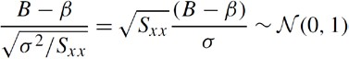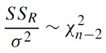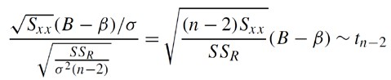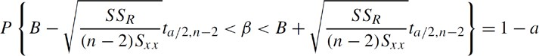

Unknown

~Normal

~Square root

of 𝜒𝜒2 /(𝑛𝑛 − 2)

𝑛𝑛−2

𝑃𝑃 𝑡𝑡30 > 2.04 = 0.025

**SE**(𝜷𝜷�𝟏𝟏)



Ross

©copyright CIEL 2015 **28**

### Assessing Accuracy of Coefficient Estimates

#### Confidence intervals using standard errors [cont.]

* + That is, there is approximately a 95% chance that the interval

𝑃𝑃 𝑡𝑡30 > 2.04 = 0.025, 𝑃𝑃 𝑡𝑡30 > 2.75 = 0.005

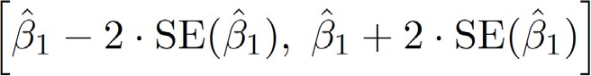

* + - It will contain the true value of 𝛽𝛽1 (under a scenario where we got repeated samples like the present sample)
  + For the advertising data, the 95% confidence interval for 𝛽𝛽1 is [0:042; 0:053]

Ross



©copyright CIEL 2015 **29**

### Hypothesis Testing

#### Standard errors can also be used to perform hypothesis tests on the coefficients.

* The most common hypothesis test involves testing the null hypothesis of
  + 𝐻𝐻0: There is no relationship between 𝑋𝑋 and 𝑌𝑌 versus the alternative hypothesis
  + 𝐻𝐻𝐴𝐴: There is some relationship between 𝑋𝑋 and 𝑌𝑌

#### Mathematically, this corresponds to testing



* + 𝛽𝛽1 = 0
    - The model reduces to 𝑌𝑌 = 𝛽𝛽0 + 𝜖𝜖
    - 𝑋𝑋 is not associated with 𝑌𝑌

©copyright CIEL 2015 **30**

### Hypothesis Testing [cont.]

#### To test the null hypothesis, we compute a 𝑡𝑡-statistic, given by

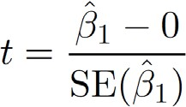

* + This will have a 𝑡𝑡-distribution with 𝑛𝑛 − 2 degrees of freedom, assuming 𝛽𝛽1 = 0
  + Using statistical software, it is easy to compute the probability of observing any value equal to 𝑡𝑡 or larger
  + We call this probability the 𝑝𝑝-value.

Ross



* Significance level 𝛾𝛾 test of 𝐻𝐻0

𝑣𝑣 value:

𝑃𝑃 𝑡𝑡30 > 2.04 = 0.025, 𝑃𝑃 𝑡𝑡30 > 2.75 = 0.005

©copyright CIEL 2015 **31**

### [Review] Inference Concerning 𝜷𝜷

#### Hypothesis testing for 𝛽𝛽: e.g., response not depending on input?





* + From distribution of 𝛽𝛽:



Unknown



~Normal

~Square root of

𝜒𝜒2

𝑛𝑛−2

/(𝑛𝑛 − 2)



* + Significance level 𝛾𝛾 test of 𝐻𝐻0



𝑣𝑣 value:





𝑃𝑃

𝑡𝑡30 > 2.04

= 0.025, 𝑃𝑃

= 0.005

©copyright CIEL 2015 **32**

𝑡𝑡30 > 2.75

### Results for Advertising Data

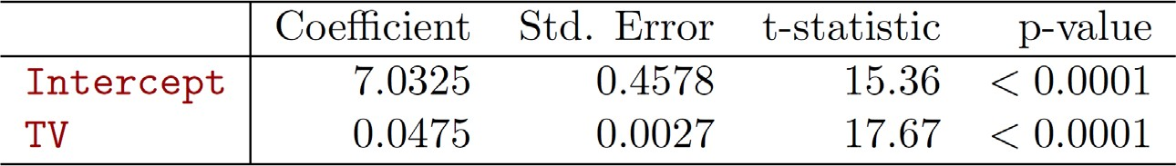𝛽𝛽0 

𝛽𝛽1 

 𝐻𝐻0 is rejected because of low 𝑝𝑝-value Thus, Sales is associated with TV

©copyright CIEL 2015 **33**

### Assessing Overall Accuracy of Model

#### Residual Standard Error

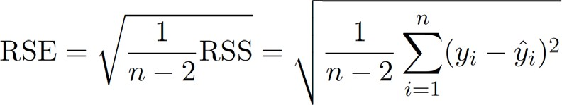

Ross

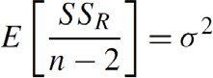

* + Residual sum-of-squares (RSS):



#### 𝑅𝑅-squared (𝑅𝑅2) or fraction of variance explained is

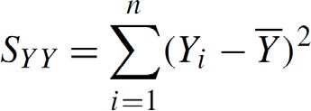

* Coefficient of determination

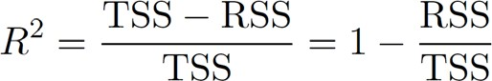

Ross

* + Total sum of squares (TSS)



©copyright CIEL 2015 **34**

### Assessing Overall Accuracy of Model [cont.]

#### 𝑅𝑅2 = 𝑟𝑟2 in this simple linear regression setting

* + 𝑟𝑟 : correlation between 𝑋𝑋 and 𝑌𝑌

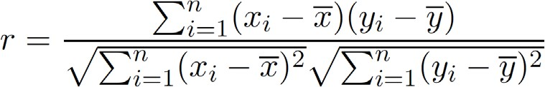

Ross

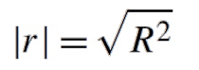

o −1 ≤ 𝑟𝑟 ≤ 1

o Only for a single pair of variables

o

©copyright CIEL 2015 **35**



# Preliminaries for



**Multiple Linear Regression: [Ross] Ch9**

#### Basics for Linear Regression

* Simple linear regression
* Preliminaries for multiple linear regression
* Summary & Next class

©copyright CIEL 2015 https://ciel.seoultech.ac.kr/

**Multiple Linear Regression**

#### Linear regression of response on more than one (i.e., multiple) independent variable



* + 𝑒𝑒 : random error normally distributed with mean 0 and variance 𝜎𝜎2



* + Residual sum of squares (RSS):

©copyright CIEL 2015 **37**

### [FYI] Matrix Form for Multiple Linear Regression

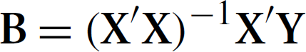

#### **Y**: 𝑛𝑛 × 1, **X**: 𝑛𝑛 × 𝑝𝑝, 𝜷𝜷: 𝑝𝑝 × 1, **e**: 𝑛𝑛 × 1 where 𝑝𝑝 ≡ 𝑘𝑘 + 1

**Normal equation**



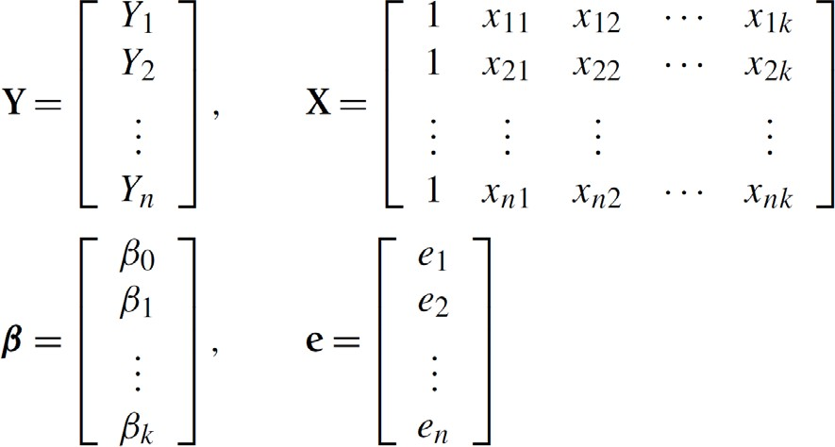©copyright CIEL 2015 **38**

### [FYI-Advanced] Least-Square Approximation



where the objective is the sum of squares of the residuals.

This problem can be solved analytically by expressing the objective as the convex quadratic function



#### A point minimizes if and only if



, if and only if satisfies so-called normal equations



which always have a solution. Since we assume the columns of are independent, the least- squares approximation problem has the unique solution



©copyright CIEL 2015 **39**

### [FYI-Advanced] Normal Equations

#### is called a normal matrix whenever

* For an system the associated system of normal equations is defined to be the system



* is always consistent, even when is not consistent.
* When is consistent, its solution set agrees with that of
* when is inconsistent, the normal equations provide least squares solutions to

❑ 

solution is

has a unique solution if and only if  in which case the unique

* When is consistent and has a unique solution, then the same is true for  and the unique solution to both systems is given by 

©copyright CIEL 2015 **40**



**Summary & Next Class**

#### Basics for Linear Regression

* Simple linear regression
* Preliminaries for multiple linear regression
* Summary & Next class

©copyright CIEL 2015 https://ciel.seoultech.ac.kr/

### Summary

#### Basics for linear regression: 𝑌𝑌 = 𝛼𝛼 + 𝛽𝛽𝑥𝑥 + 𝑒𝑒 (𝑒𝑒~normal distribution with mean 0 and variance 𝜎𝜎2)

* + Distributions of regression parameters: described by normal distributions
  + Variance of random error: 𝜎𝜎2 = 𝐸𝐸 𝑆𝑆𝑆𝑆𝑅𝑅 /

𝑛𝑛 − 2

* + Inferencing concerning 𝛼𝛼 and 𝛽𝛽 using 𝑡𝑡-distribution with dof 𝑛𝑛 − 2
  + Coefficient of determination vs. sample correlation coefficient

#### Simple linear regression: 𝑌𝑌 = 𝛽𝛽0 + 𝛽𝛽1𝑥𝑥 + 𝜖𝜖

* + A simple approach to supervised learning
  + All derived from basics for linear regression
  + 𝑌𝑌 associated with 𝑥𝑥? Hypothesis testing 𝐻𝐻0: 𝛽𝛽1 = 0
  + 𝑅𝑅2: fraction of variance explained (equal to square of sample correlation coefficient)

#### Preliminaries for multiple linear regression

* + Linear regression with multiple predictors
  + Least square estimator of regression parameters: normal equation

©copyright CIEL 2015 **42**

### Assignments

* eClass > Assignments
  + Upload 2 or 3 files (do not compress them)
* Python practices in today’s lecture
  + Upload a single ipynb file
  + Referring to the lecture slides marked with [P]
  + File name: “StudentID” + “_AssignmentNo w/ 2 digits” + “_1.ipynb”, e.g., **20211234_02_1.ipynb**
* Textbook exercise problems for today’s lecture
  + Conceptual
    - Solving the given problems, then upload your own solution (only docx/hwp formats, not pdf/jpg/bmp etc.)
    - Only include your answers (not need to describe problems)
    - File name: “StudentID” + “_AssignmentNo w/ 2 digits” + “_2.ipynb”, e.g., **20211234_02_2.docx**
  + Applied
    - Implement your Python code for the given problems, then upload another single ipynb file
    - File name: “StudentID” + “_AssignmentNo w/ 2 digits” + “_1.ipynb”, e.g., **20211234_02_3.ipynb**
* If not complying with the above policies, some penalty on assignment scores may be given.

©copyright CIEL 2015 **43**

### Course Schedule (Tentative)

|  |  |  |  |  |
| --- | --- | --- | --- | --- |
| **Week** | **Topics** | **Note** | **Date (W)** | **Date (M)** |
| 1 | Orientation, Statistical Learning (Ch2) | Online | 03/03 | 03/08 |
| 2 | Statistical Learning (Ch2), Python Programming | Online | 03/10 | 03/15 |
| 3 | Probability & Statistics | Online | 03/17 | 03/22 |
| 4 | Probability & Statistics | Online | 03/24 | 03/29 |
| 5 | Linear Regression (Ch3) | Online | 03/31 | 04/05 |
| **6** | Linear Regression (Ch3) | Online | 04/07 | 04/12 |
| 7 | Classification (Ch4) | Online | 04/14 | 04/19 |
| 8 | **Midterm exam** | **7pm or Class hours (W1-W7)** | **04/21or26** | **04/21or26** |
| 9 | Resampling Methods (Ch5) | Online | 04/28 | 05/03 |
| 10 | Linear Model Selection and Regularization (Ch6) | Online | 05/05 | 05/10 |
| 11 | Moving Beyond Linearity (Ch7) | Online | 05/12 | 05/17 |
| 12 | Tree-Based Methods (Ch8) | Online | 05/19 | 05/24 |
| 13 | Support Vector Machines (Ch9) | Online | 05/26 | 05/31 |
| 14 | Unsupervised Learning (Ch10) | Online | 06/02 | 06/07 |
| 15 | **Final exam** | **7pm or Class hours (W9-W14)** | **06/09or14** | **06/09or14** |

©copyright CIEL 2015 **44**